DATA FLOW DIAGRAM

CONTEXT LEVEL

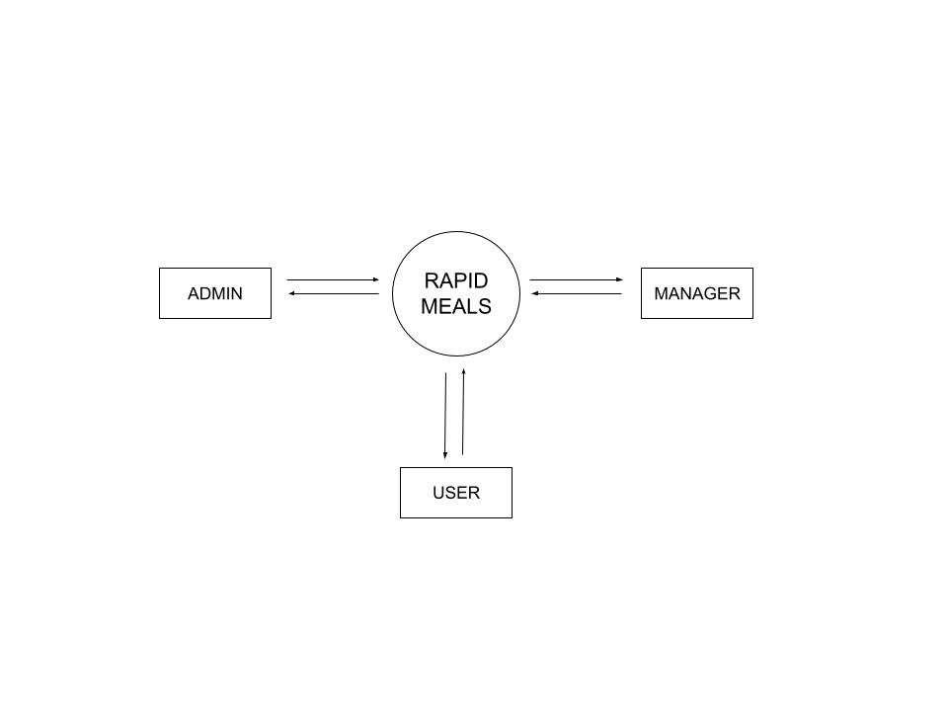

Level 0

Level 0 DFD for Rapid Meals

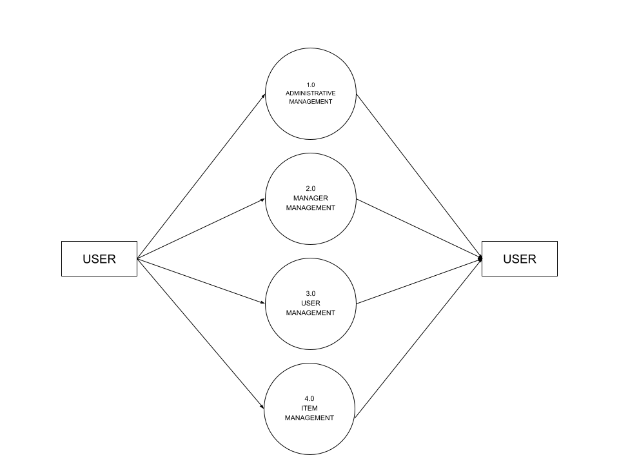

Level 1

Level 1 for admin

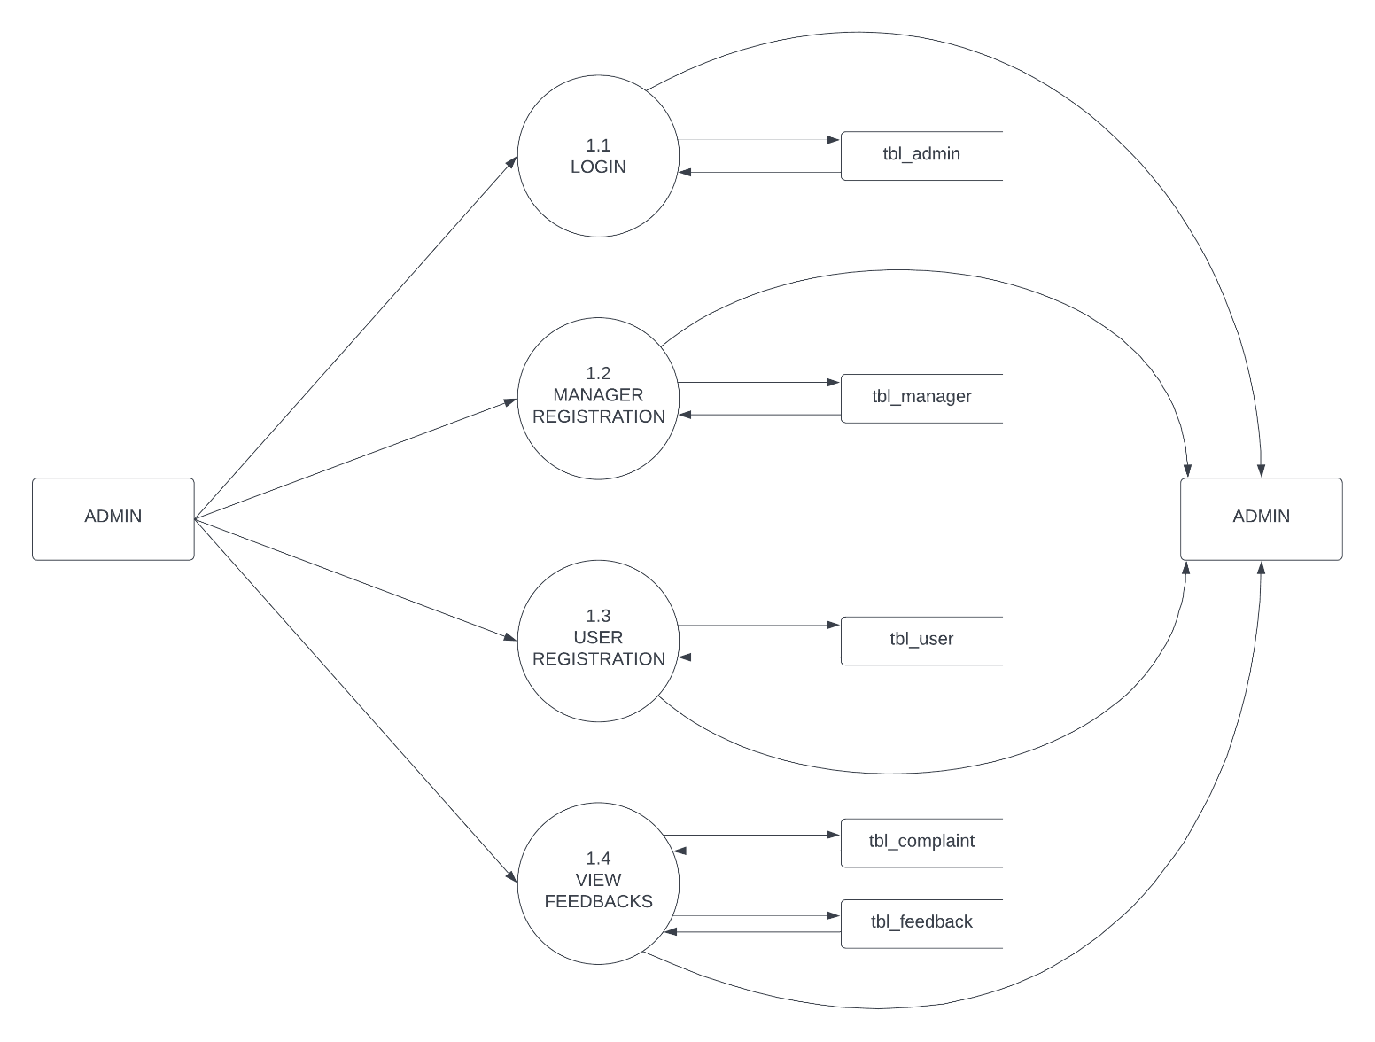

Level 1 for manager
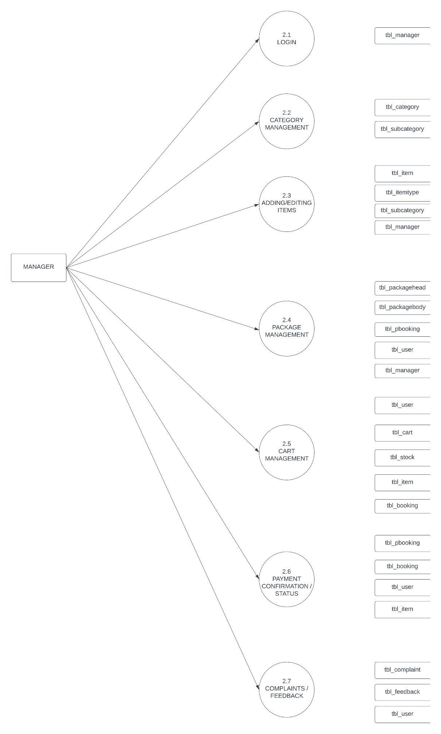
Level 1 for user

